CSA6303 - THREAT INTELLIGENCE AND NETWORK SECUR
Assessment Tool 1: CONCEPT MAPPING
Faculty : Dr.V.Parthipan SLOT A

Topics: Network Security Fundamentals | Security Goals (CIA Triad) | Types of Network Threats |Introduction to Threat Intelligence Types of Threat Intelligence (Strategic, Tactical, perational) — Threat Intelligence Lifecycle — Applications in IT Industry
CO1: Interpret security principles, network threats, and the role of threat intelligence in cybersecurity.

Total: 50
Student Name : V.Rakshmitha
Register number: 192465052

Code of Conduct:

I V.Rakshmitha-192465052 (Name / Reg No) certify that this submission is my original work and that I have adhered to the guidelines specified for this assessment. I understand that any violation of academic integrity rules will result in disciplinary action.

Signature of the student
V.Rakshmitha
CO1 – Concept Mapping Questions
No. | Concept-Mapping Question
1 | Construct a comprehensive concept map explaining the foundations of Network Security. Connect network security fundamentals with security objectives, the CIA Triad (Confidentiality, Integrity, and Availability), network assets, vulnerabilities, threats, and protective measures, and explain how these concepts collectively support secure network operations.
2 | Develop a concept map illustrating the CIA Triad as the foundation of network security. Relate Confidentiality, Integrity, and Availability to different types of network threats and demonstrate how a single threat can affect one or more security goals.
3 | Construct a concept map classifying different types of Network Threats and their potential impact on security goals. Connect threats such as malware, phishing, denial-of-service, spoofing, eavesdropping, and unauthorized access with the CIA Triad and explain the resulting security implications.
4 | Develop an integrated concept map connecting Network Security Fundamentals, Network Threats, and Threat Intelligence. Show how identifying assets, vulnerabilities, and threats leads to the collection and analysis of threat information and ultimately supports informed security decisions.
5 | Construct a concept map explaining the concept of Threat Intelligence and its role in modern network security. Relate threat actors, indicators, vulnerabilities, attack patterns, threat information, analysis, and actionable intelligence to demonstrate how Threat Intelligence helps organizations anticipate and respond to network threats.
6 | Develop a comparative concept map of Strategic, Tactical, and Operational Threat Intelligence. Connect each type with its purpose, target audience, time horizon, information requirements, decision-making process, and appropriate network-security use cases, and analyze how the three intelligence types complement one another.
7 | Construct a concept map representing the complete Threat Intelligence Lifecycle. Connect planning/direction, collection, processing, analysis, dissemination, and feedback with the identification of network threats and security requirements, showing how feedback continuously improves the intelligence process.
8 | Develop an end-to-end concept map showing how a network threat progresses from identification to actionable Threat Intelligence. Connect network security fundamentals, CIA security goals, threat detection, intelligence collection, processing, analysis, dissemination, and response, and explain the relationship between each stage.
9 | Create a scenario-based concept map for an organization experiencing a major network attack. Integrate the CIA Triad, types of network threats, Strategic Intelligence, Tactical Intelligence, Operational Intelligence, and the Threat Intelligence Lifecycle to demonstrate how the organization can understand, prioritize, and respond to the threat.
10 | Design a comprehensive concept map demonstrating the applications of Network Security and Threat Intelligence in the IT industry. Connect network security fundamentals, CIA Triad, network threats, Threat Intelligence, Strategic/Tactical/Operational Intelligence, and the Threat Intelligence Lifecycle with applications such as threat monitoring, incident response, vulnerability management, risk assessment, security operations, and organizational decision-making.

Recommended Bloom's Levels
- Analyze (L4): Q1, Q2, Q3, Q4, Q5, Q7, Q8
- Evaluate (L5): Q6, Q9
- Create (L6): Q10
These questions are deliberately framed so that students must connect concepts in a hierarchy/relationship map, rather than simply reproduce definitions.
Answers:
Q9:Create a scenario-based concept map for an organization experiencing a major network attack. Integrate the CIA Triad, types of network threats, Strategic Intelligence, Tactical Intelligence, Operational Intelligence, and the Threat Intelligence Lifecycle to demonstrate how the organization can understand, prioritize, and respond to the threat.
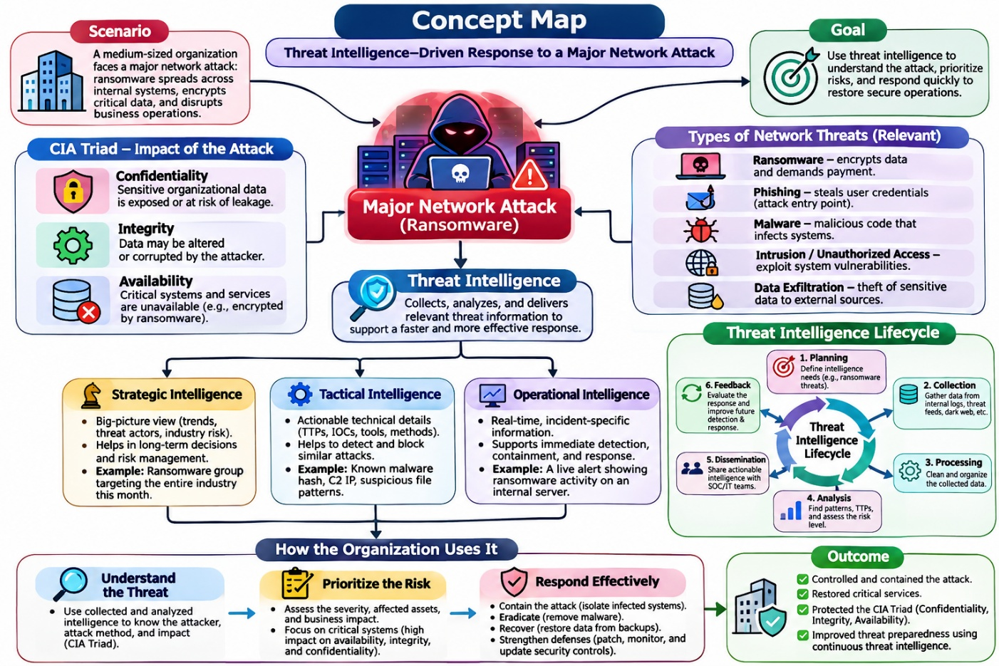
1. Scenario
A medium-sized organization experiences a major network attack in which ransomware spreads across its internal systems. The attacker encrypts important data, disrupts business operations, and may steal confidential information. The organization uses threat intelligence to identify the attack, understand its severity, and respond quickly.
2. CIA Triad – Impact of the Attack
The CIA Triad represents the three main principles of information security.
- Confidentiality: Sensitive information, such as customer details and financial records, may be exposed or stolen.
- Integrity: The attacker may modify, corrupt, or delete important organizational data.
- Availability: Systems and services may become unavailable because ransomware encrypts files or disrupts the network.
The organization must protect all three principles to maintain security.
3. Types of Network Threats
The organization identifies different threats that may cause or contribute to the attack.
- Ransomware: Encrypts files and demands payment to restore access.
- Phishing: Uses deceptive emails or messages to steal credentials or trick employees into opening malicious files.
- Malware: Malicious software that infects systems and performs harmful activities.
- Intrusion or Unauthorized Access: Attackers enter systems by exploiting vulnerabilities or stolen credentials.
- Data Exfiltration: Sensitive information is transferred outside the organization without authorization.
Identifying these threats helps the security team understand how the attack occurred and how to prevent further damage.
4. Threat Intelligence
Threat intelligence is the process of collecting, analyzing, and sharing information about cyber threats. It helps the organization understand the attacker, prioritize risks, and choose suitable security measures.
Threat intelligence is divided into three levels:
- Strategic Intelligence: Provides a long-term view of threats, attacker groups, industry risks, and business impact. Management uses it to plan security investments and improve policies.
- Tactical Intelligence: Explains the attacker's tactics, techniques, and procedures (TTPs). It helps security teams recognize attack patterns and improve detection rules.
- Operational Intelligence: Provides information about ongoing attacks, campaigns, and attacker activities. It helps the incident response team make immediate decisions during an active incident.
5. Threat Intelligence Lifecycle
The Threat Intelligence Lifecycle is a continuous process that turns raw information into useful security decisions.
- Planning and Direction: Define intelligence requirements, identify critical assets, and decide what information is needed.
- Collection: Gather information from network logs, security tools, threat feeds, and trusted open-source intelligence.
- Processing: Filter, clean, organize, and prepare collected data for analysis.
- Analysis: Identify attack patterns, assess the threat's severity, and determine which systems are at risk.
- Dissemination: Share relevant findings with the security operations centre (SOC), IT team, management, and incident responders.
- Feedback: Evaluate whether the response was effective and update intelligence requirements for future incidents.
The lifecycle repeats as new information becomes available and the attack changes.
6. How the Organization Understands, Prioritizes, and Responds
The organization applies threat intelligence in three stages:
- Understand the threat: Analyze logs and indicators to identify the attack method, affected systems, and possible data exposure.
- Prioritize the risk: Assess the severity of the attack, business impact, and criticality of affected systems. Systems containing sensitive data or supporting essential services receive urgent attention.
- Respond effectively: Isolate infected systems, block malicious indicators, remove malware, patch vulnerabilities, restore clean backups, and strengthen monitoring.
7. Expected Outcome
By combining the CIA Triad, network threat analysis, the three levels of intelligence, and the intelligence lifecycle, the organization can contain the attack, restore critical services, reduce data loss, and improve its future security preparedness.
Conclusion: Threat intelligence enables an organization to move from simply detecting a cyberattack to understanding its causes, prioritizing the most serious risks, and responding effectively. The continuous threat intelligence lifecycle helps protect confidentiality, integrity, and availability while strengthening overall cybersecurity.
Q10. Design a comprehensive concept map demonstrating the applications of Network Security and Threat Intelligence in the IT industry.
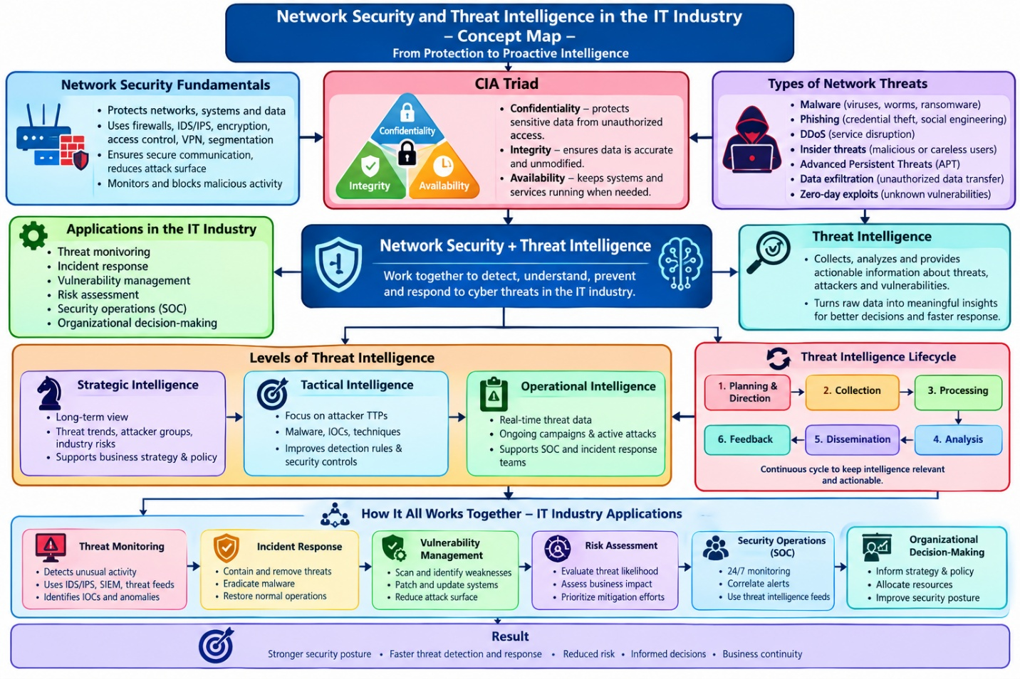
Explanation of the Concept Map: Network Security and Threat Intelligence in the IT Industry
1. Network Security Fundamentals
Network security protects an organization's computers, servers, networks, and data from unauthorized access, cyberattacks, and misuse.
It uses security mechanisms such as:
- Firewalls: Block unauthorized network traffic.
- IDS/IPS: Detect and help prevent suspicious network activity.
- Encryption: Protects data from being read by unauthorized users.
- Access control: Ensures only authorized users can access resources.
- VPN: Provides a secure connection over a network.
These fundamentals create the foundation for protecting IT infrastructure.
2. CIA Triad
The CIA Triad represents the three main goals of information security.
- Confidentiality: Ensures sensitive data is accessible only to authorized people.
- Integrity: Ensures data remains accurate and is not modified without authorization.
- Availability: Ensures systems, applications, and information are available when required.
For example, a company uses encryption to protect confidentiality, file integrity checks to detect unauthorized changes, and backups to restore availability.
3. Types of Network Threats
Network threats are malicious activities that can compromise systems, information, or services.
- Malware: Malicious software, including viruses, worms, and ransomware.
- Phishing: Deceptive messages designed to steal credentials or deliver malware.
- DDoS attacks: Overwhelm a server or network with traffic, making services unavailable.
- Insider threats: Security risks caused by employees or other trusted users, intentionally or accidentally.
- Advanced Persistent Threats (APTs): Long-term, targeted attacks against an organization.
- Data exfiltration: Unauthorized transfer of sensitive information outside an organization.
- Zero-day exploits: Attacks that exploit vulnerabilities before an effective fix is available.
Understanding these threats helps security teams select suitable preventive and defensive measures.
4. Threat Intelligence
Threat intelligence is the process of collecting, analyzing, and sharing information about cyber threats, attackers, and vulnerabilities.
It transforms raw information, such as network logs and suspicious IP addresses, into useful knowledge that helps organizations detect attacks and make informed security decisions.
For example, if threat intelligence identifies an IP address associated with a known malicious campaign, the security team can investigate related traffic and block it when appropriate.
5. Levels of Threat Intelligence
Threat intelligence is divided into three levels based on the type of decision or action required.
Strategic Intelligence
- Provides a long-term view of cyber risks and attacker trends.
- Supports management decisions, security policies, and budget planning.
- Example: Learning that ransomware attacks against the financial sector are increasing and investing in stronger backup systems.
Tactical Intelligence
- Explains attackers' tactics, techniques, and procedures (TTPs).
- Helps security teams improve detection rules and defensive controls.
- Example: Understanding how attackers use phishing emails and stolen credentials to enter a network.
Operational Intelligence
- Provides information about ongoing attacks, campaigns, and attacker activities.
- Supports immediate investigation and incident response.
- Example: Receiving information about an active ransomware campaign targeting the organization's servers.
Together, these three levels support long-term planning, improved defenses, and immediate action.
6. Threat Intelligence Lifecycle
The Threat Intelligence Lifecycle is a continuous process that converts threat data into actionable intelligence.
- Planning and Direction: Identify security goals and decide what information is required.
- Collection: Gather data from network logs, threat feeds, security tools, and trusted external sources.
- Processing: Filter, organize, and prepare the collected information for analysis.
- Analysis: Identify patterns, assess risks, and determine the significance of potential threats.
- Dissemination: Share findings with the SOC, IT team, incident responders, and management.
- Feedback: Evaluate the results and improve future intelligence collection and analysis.
The lifecycle repeats continuously because cyber threats and attacker techniques change over time.
7. Applications in the IT Industry
The combination of network security and threat intelligence supports several important IT security activities.
Application | Purpose
Threat Monitoring | Continuously detects suspicious activities using logs, alerts, and threat indicators.
Incident Response | Investigates, contains, and removes threats, then restores affected systems.
Vulnerability Management | Identifies, assesses, prioritizes, and fixes security weaknesses.
Risk Assessment | Evaluates the likelihood and impact of threats to prioritize protection.
Security Operations Centre (SOC) | Monitors security events, investigates alerts, and coordinates defensive actions.
Organizational Decision-Making | Helps management select security investments, policies, and priorities based on risk.

For example, a SOC may detect suspicious traffic, use threat intelligence to identify a possible attack, andnotify the incident response team. The vulnerability management team then fixes the exploited weakness, while management evaluates the wider business risk.
8. How Everything Works Together
The concept map demonstrates the relationship between all the topics:
- Network security fundamentals establish protective controls.
- The CIA Triad defines what the organization must protect.
- Network threat analysis identifies possible attacks and their effects.
- Threat intelligence explains the attackers and provides information for action.
- Strategic, tactical, and operational intelligence support different decisions and response needs.
- The Threat Intelligence Lifecycle keeps information relevant and actionable.
- IT applications use these insights to monitor threats, respond to incidents, manage vulnerabilities, assess risks, and guide organizational decisions.
9. Expected Results
Applying these concepts together helps organizations achieve:
- Stronger network and data protection.
- Faster threat detection and incident response.
- Reduced cybersecurity risk and potential business losses.
- Better-informed security decisions.
- Improved business continuity and resilience.
Conclusion: Network security provides the controls needed to protect IT systems, while threat intelligence helps organizations understand threats and respond effectively. Together, they enable proactive defense, better risk management, and stronger cybersecurity across the IT industry.

